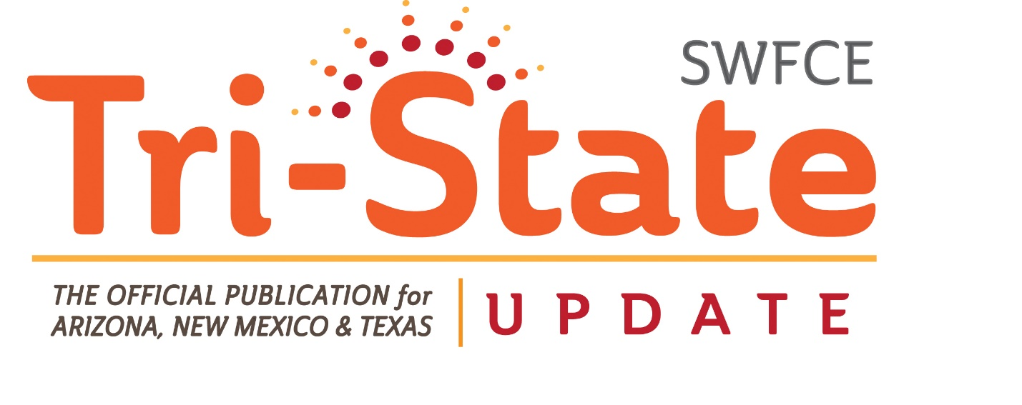*Fall 2018*

**MESSAGE from the PRESIDENT**

**“SWFCE is HIGH-FLYING”**

Happy End of the Summer! Really, I'm ready for some cool, not hot, windy/dusty weather.

We are hard at work for the first ever Southwest FCE Conference. It will be in Albuquerque, NM, Sept. 28-29. Registration and Conference info will be in the following pages

I was unable to attend National Conference this year, due to a niece's wedding in Colorado. It was the first time since 1985 that I have missed one. I loved being in CO, but really missed attending the National Conference in Austin, TX.

Marian Hannon attended as the SWFCE Alternate voting delegate and she'll give a report at our Conference. Bob attended with her. Martha Crawford will also give a report.

Included in this issue is information on the upcoming SWFCE Conference—registration, hotel information, tentative agenda, workshops/presentations, etc., & membership form. Currently I am awaiting confirmation that Scott and Bonnie Teeples will be able to attend. SWFCE will pick up their cost of registration.

**HOTEL INFORMATION for CONFERENCE**

The **SWFCE Conference** will be held at:

Holiday Inn and Suites

Albuquerque Airport

1921 Yale Blvd. SE

Albuquerque, NM 87106

The hotel has asked that I make room reservations and provide the list of names/roommates. What I need from you, if you haven't already told me, is if you want a king or 2 queens.

Cost of rooms: 112.70, all inclusive, per night for 2 queens

101.01, all inclusive, per night for a king

Check in is Sept. 21 and check out is either the Sept 29 or 30.

We will have the Board Room for our meeting. Water service will be provided. Cost is $193.50 for the room. Additional charges if we request items.

Restaurants Close-by (some of them):

Applebee's

Chili's

Buffalo Wild Wings

Fuddruckers

The hotel is close by the airport if you wish to fly. There’s a free shuttle as well.

**"What we ponder and what we think about sets the course of our life. Any day we wish, we can discipline ourselves to change it all. Any day we wish, we can open the book that will open our mind to new knowledge. Any day we wish, we can start a new activity. Any day we wish, we can start the process of life change. We can do it immediately, or next week, or next month, or next year.**

**"We can also do nothing. We can pretend rather than perform. And if the idea of having to change ourselves makes us uncomfortable, we can remain as we are. We can choose rest over labor, entertainment over education, delusion over truth, and doubt over confidence. The choices are ours to make. But while we curse the effect, we continue to nourish the cause. As Shakespeare uniquely observed, "the fault is not in the stars, but in ourselves." We created our circumstances by our past choices. We have both the ability and the responsibility to make better choices beginning today."**

******************************************************************

 **SWFCE FUNDRAISER** 

We will once again have tickets to sell for a cash prize. The tickets will be $5 each or 5 for $20.

This is our only fundraiser. This helps to send the voting delegate to National Conference.

Personally, I feel it would be even better if we could raise a bit more money and use it for outside speakers or other projects. But that's just me.....

**NOMINATIONS**

We will be accepting nominations for the following offices:

President Elect/President 3-year term (2020-2012)

Secretary 1-year, to complete current term (2019)

can run for a full-term

Next year, we will be looking for someone to run for Secretary and Vice President. The following year, it will be the position of Treasurer.

***PLEASE consider running for an office. Yes, there is work involved, but truly not a lot. The President is required to attend National Conference or appoint an alternate. The Treasurer has the most to do and Marian has done an excellent job for years.***

**Workshops/Presentations**



**"How Aging Affects Our Senses", Martha Crawford, Program Coordinator, National FCE**

**ACWW, Bonnie Teeples, Past National FCE President**



**TENTATIVE BUSINESS MEETING AGENDA**

**Friday, Sept. 28,2018**

Call to Order Margaret Polen

Welcome & Introductions

Pledge of Allegiance All

Creed All

Mission & Vision All

Rules of Conference TBA

Motion to Set Agenda

Appointment of Secretary

Minutes TBA

Communications/Correspondence TBA

Financial Report Marian Hannon

Reports:

Investment Committee Bob Hannon, Steve

Polen, Mary Bender

Honor Fund Margaret Polen

Legacy Fund Bob Hannon

Website

Newsletter Steve Polen

Heart of FCE TBA

ACWW Bonnie Teeples

National Conference Susie Martell,

Richard Martell,

Bob Hannon,

Marian Hannon

E-mail Votes to Minutes

Appointment of Investment Cmt.

Appointment of Budget Cmt.

Appointment of Marian H. as alternate

2019 Fundraiser/Tickets

Special Orders:

Distribution of 2019 Ticket

Skyping for SWFCE meeting

New Business:

2019 Proposed Budget Budget Committee

2020 Fundraiser/s

Publicity Committee

2019 SWFCE Conf. Date

Assignments

Theme

Place

Programs/Workshops

Heart of FCE Nomination, 2019

Nominations:

President Elect (2019, then 2020-2022)

Secretary (2019, can run for full term after)

Elections

Dates

October 15-International Rural Women’s Day, ACWW

November17, Yuma County FCE Community Bazaar

March 14, Drawing for Cash Prize, Yuma

March, Skype Meeting for SWFCE?

April 4-10-ACWW Triennial, Melbourne, Australia

July 2019, St. Louis, MO, NAFCE National Conf

October 13-19, National FCE Week

October 20-26, CHARACTER COUNTS! Week

November 24-30, 2019 National Family Week

Announcements

Installation

Adjourn

*An agenda will be provided at Conference. If you have anything to add, please let the President know by September 14.*

**There will be a program and action planning session held Saturday at Conf. Bring your ideas and how to carry them out.**

**MISSION…To strengthen individuals, families, and communities through continuing education, developing leadership, and community action.**



**REGISTRATION for SWFCE 2018 CONFERENCE**

Name: ________________________________________________

Address: ______________________________________________

City/State/Zip: _________________________________________

Phone Number: _________________________________________

Enclosed Amount/Check Number: ___________ ____________

~~~~~~~~~~~~~~~~~~~~~~~~~~~~~~~~~~~~~~~~~~~~~~~~~~~~~~~

Cost is $25.00 per person.

Send top half with check made to AZFCE (Yes, AZFCE) and Mail to:

Marian Hannon

1693 Petunia Pl.

Oro Valley, AZ 85737

Registration must be received by: Sept. 18, 2018Breakfast is provided by the hotel. Lunch and dinner will be on your own.

**BOTH registration *AND* membership checks: AZFCE**

  **SWFCE**

**2019 MEMBERSHIP FORM**

**\*\*\*Type or Print Clearly\*\*\***

**\*\*\*Do Not Abbreviate City, County, or State Street Names\*\*\***

Date _______________ Current Member ID # _______________ E-Mail _________________________

First Name _____________________ M.I. _____ Last Name ________________________________

Mailing Address _______________________________________________________________________

City ___________________________ State _______ Zip Code _______________________________

Council ____________________________ Club Name _____________________________________

Phone No. _____________________

Family Membership: (Please list) Spouse Name_________________________________________ Dependent Child(ren)__________________________________

|  |  |  |  |
| --- | --- | --- | --- |
| ***Dues*** | ***Regular*** | ***Family*** | ***Senior (80+ years)*** |
| **National** | $20.00 | $30.00 | $ 16.50 |
| **State** | $15.00 | $20.00 | $ 10.00 |
| **Yuma County** | $4.00 |  | $4.00 |
|  |  |  |  |
| **TOTAL** |  |  |  |

**Sign and send with total membership dues to Club Treasurer by ___________________________**

New Member (Never belonged to FCE before)

Member Signature ____________________________________________________

Must be original signature, copies will not be accepted